**Image Segmentation (EN 2550)**

Niruhan Viswarupan 140422H

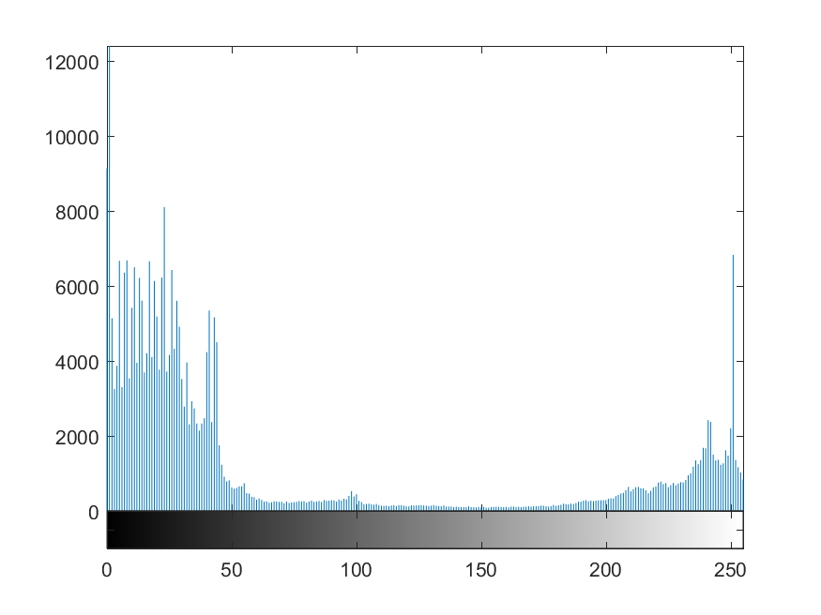

Histogram of the Image

1. Thresholding

Method: Input image is converted into grayscale image. Every pixel of the gray image is visited and is the value is above a threshold it is passed into the output.

Code snippet:

for i=1:h

for j=1:w

if (imGray(i, j) > threshold)

thresholdedImGray(i, j) = imGray(i, j);

end

end

end



Original Image



After Thresholding with 150

Result:

Analysis: This simple technique is powerful but only works when there is a good intensity variation between object of interest and background. The histogram of the image used is as follows. Note that it has two peaks separated by a valley. Around intensity of 150 the valley is minimum. So choosing 150 as threshold will result in a clearly segmented image.

2. Region Growing

Method: Select a seed pixel and pass it to the output. Then check its adjacent 4 pixels and if their intensities differ from the seed’s by less than a stipulated threshold then recursively call regionGrow function on the adjacent pixels.

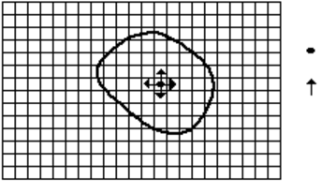

Seed Pixel

Direction of growth

Start Growing a Region

Grown Pixel

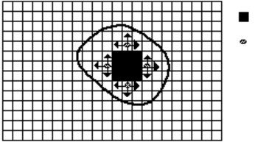

Pixels being considered

Growing Process after a few Iterations

Code Snippet:

if (x-1>0)

if (abs(image(x, y)-image(x-1,y))<threshold)

%output(x-1,y)=-2;

newSeed = [x-1, y];

regionGrow(newSeed, image, threshold);

end

end

Result:



Original Image

Analysis: Note that when using a single seed the dark regions inside the object of interest are not passed onto the output. We could eliminate it by selecting multiple seeds. Note the depressions inside the red circle in the following image.

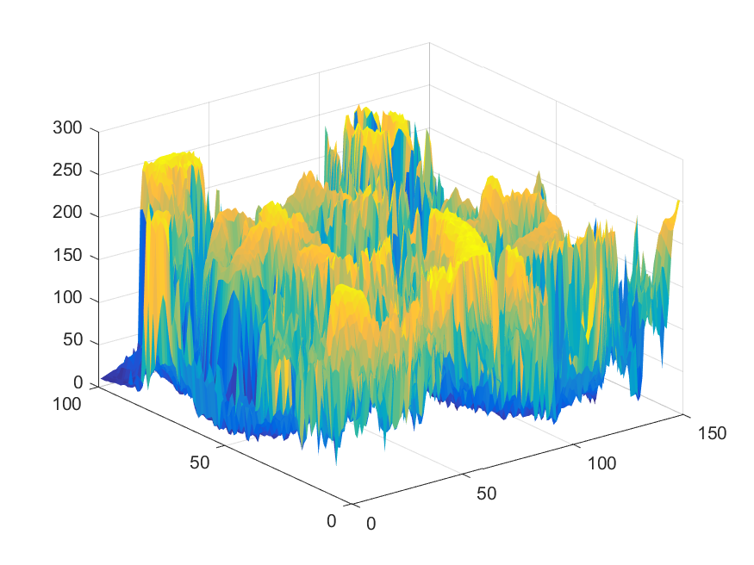

3D Plot of Intensities of the Input Image



Region Grown with One Seed



With Multiple Seeds at Dark Regions in The face